

**Disclaimer: The content is curated from online/offline resources and used for educational purpose only**



**LAB MANUAL**

**Unit I – Foundation of Green Skilling, Sustainability and AI Contributions**

**Unit I – Foundation of Green Skilling, Sustainability and AI Contributions**

**Lab - 5**

**AI-Driven Circular Economy and Green Skilling in Waste Management**

**Introduction**

Environmental concerns such as issues of waste management and the depletion of natural resources have made the circular economy an emerging concept for sustainability. Waste reduction, reuse, and recycling of products have gained importance to reduce adverse environmental effects. The circular economy is driven by the use of artificial Intelligence, and using improved efficiency is beginning in the handling of waste management; green skilling programs equip workers for operating in the new environment.

**Background**

The traditional linear economic model—take, make, dispose—has led to excessive resource extraction, massive waste generation, and environmental degradation. The circular economy seeks to address these challenges by creating closed-loop systems where resources are continuously cycled back into production.

However, implementing the circular economy in waste management is not without its challenges. To achieve this transition, two key components are needed:

1. **Advanced technologies** that optimize waste sorting, recycling, and reuse.
2. **Green skilling** programs to develop a workforce capable of managing these new technologies and processes effectively.

**AI's Role in the Circular Economy and Waste Management**

AI has brought many improvements to waste management, particularly in sorting and recycling. Machines that operate using AI in a recycling center sort waste materials faster and more efficiently than humans can, thereby increasing the percentage recycling the process by a larger percentage. In addition, AI optimizes the routes and schedules used in collecting waste with minimum carbon footprint. In Toronto, Intuitive AI- the startup-uses AI-enabled waste bins that automatically sort trash from recyclables, increase the percentage of recyclables, and will educate the user where to correctly dispose of them. The same happens with AI optimization of waste collection logistics in San Francisco: such algorithms using machine learning models suggest the most efficient route for the collection truck, thus saving money and emissions. In India, too, AI innovations have improved waste management in cities such as Surat. They help manage collection and processing better. These systems track waste levels, predict the needs for collection, and optimize routes, which leads to much-reduced operational footprints of waste management services.

AI could change the way garbage is managed almost as radically as it is some of the dynamics in processing, handling, and the collection of waste. Here's how AI is transforming different aspects of the circular economy:

In recent years, artificial intelligence (AI) has been the new buzzword in waste management as a promising avenue for the improvement of sustainability. AI is transforming the processing, handling, and recycling of wastes, raising efficiency, sustainability, and cost-effectiveness. Case Study: Current Trends of AI Applications in Waste Management: Benefits and an Example of an AI Solution Called NANDO.

**Current Trends in AI Applications in Waste Management**

1. **Machine Learning Algorithms for Waste Sorting**:
   * AI employs machine learning to classify and sort recyclables, aiming to minimize contamination in recycling streams. By accurately identifying different materials, these algorithms improve the overall quality of recyclables.
2. **Predictive Analytics for Collection Routes**:
   * Predictive analytics are used to optimize waste collection routes, leading to more efficient resource allocation. This reduces operational costs by decreasing the number of trucks required for waste collection.
3. **AI-Powered Robotics**:
   * Robotics enhanced by AI are being implemented to automate waste processing tasks, particularly in sorting. These systems can operate faster and more accurately than human workers, improving processing efficiency.
4. **IoT-Integrated AI Sensors**:
   * AI-powered sensors connected to the Internet of Things (IoT) optimize waste collection by monitoring fill levels in waste bins. This data-driven approach helps determine the optimal timing for waste collection, preventing overflow and ensuring timely service.

**Significant Benefits of AI in Waste Management**

* **Cost Reduction**: By optimizing collection routes and processes, AI reduces the need for multiple waste collection trucks, leading to significant cost savings for municipalities and waste management companies.
* **Enhanced Recycling Quality**: AI improves the quality of recycled materials by minimizing contamination, resulting in higher revenue from recycled products. Clean recyclables are more valuable in the market, incentivizing better waste separation practices.
* **Increased Recycling Rates**: AI-driven innovations streamline recycling systems, making them more user-friendly and efficient. This could potentially boost overall recycling rates, contributing to reduced environmental pollution.
* **Waste Volume Reduction**: By improving sorting accuracy, AI can significantly decrease the amount of waste sent to landfills. Increased material recovery for recycling preserves natural resources and reduces greenhouse gas emissions associated with producing new materials.

**Circular Economy and NANDO: An Example of AI in Waste Management**

The concept of a circular economy is central to sustainable practices, promoting the reuse, repair, and recycling of materials. An exemplary case of AI application in waste management is **NANDO**, developed by the Italian startup **ReLearn**. NANDO is designed to help companies optimize their waste management processes and introduces sustainable practices in waste handling.

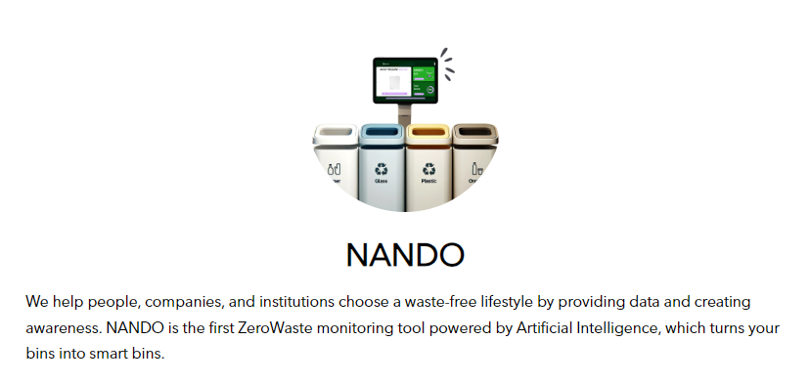

<https://aiforgood.itu.int/speaker/nando/>

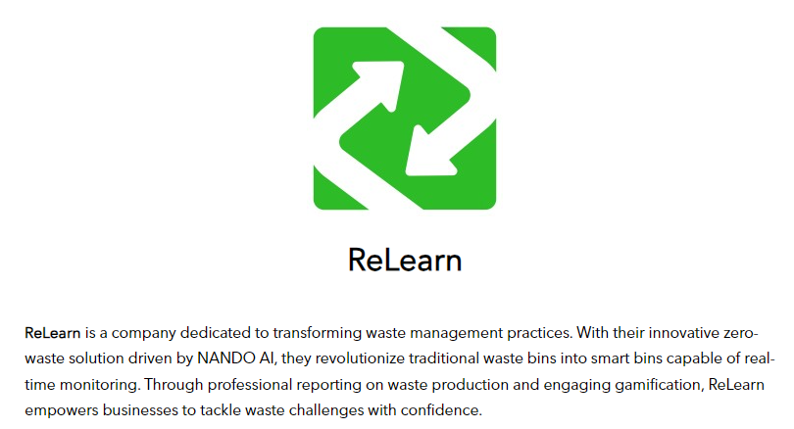

**Key Features of NANDO:**

* **Monitoring and Analysis**: NANDO tracks, analyzes, and measures waste production, providing valuable insights into recycling efforts and waste reduction strategies. This data is aggregated into a monitoring dashboard that helps clients understand their environmental impact.
* **Community Engagement**: NANDO fosters community involvement through gamification, raising awareness about waste management topics. It provides effective strategies to reduce, reuse, and recycle waste, promoting a culture of sustainability.

**Green Skilling for the Circular Economy in Waste Management**

* Added by AI Integration creates a new need for skills and competencies, and for the green skilling of workers so they are competent in operating and maintaining AI driven waste management systems. Green skilling aspects involved here include:
* Training in AI and Robotics: The programs should be focused on the ways the professionals will be able to interact with machinery and robotics-based AI in waste sorting, recycling, and other forms of waste-to-energy technologies. The maintenance of AI-driven systems is also a part of these programs.

* Data Analytics and Predictive Modelling: Training in the application of AI in predictive analytics enhances the operational efficiency of waste management professionals by forecasting waste generation and resource needs.

* Circular Economy Principles: Education in the principles of circular economy so that the worker understands the actual importance of waste reduction, material reuse, and sustainable production.
* Sustainability and Environmental Protection: Environmental law and regulation, sustainable waste management techniques, and strategies on waste reduction must be relevant to upskill the workforce on one hand but also bound with AI.

**Case Example: AI-Powered Waste Management in Action**

For example, Copenhagen has been operating an AI-pitted waste management system since 2019. That is, the system optimizes its routes in waste collection through mechanisms enabled by AI. It also analyzes performance in recycling and automates sorting at recycling plants. This also led local educational institutions to offer 'green skilling' programs educating citizens and workers on how they can operate these AI-driven technologies. This reduced up to 20% in operational costs. It assured an increase in recycling rates and public engagement with the circular economy.

**Year-Wise Progress of AI-Powered Waste Management and Efficiency Improvements**

| **Year** | **Key Development** | **Notable Example** |
| --- | --- | --- |
| **2015** | Early adoption of AI in waste sorting, improving accuracy and reducing manual labor. | ZenRobotics developed AI-driven robotic systems for sorting construction and demolition waste. |
| **2016** | AI-powered systems optimized waste collection routes, reducing fuel consumption and emissions. | Cities like San Francisco used AI to suggest efficient waste collection routes. |
| **2017** | AI and machine learning were used extensively in recycling centers to improve sorting accuracy and speed. | AMP Robotics introduced AI-enabled robots to recycle e-waste, enhancing recycling rates. |
| **2018** | AI-enabled predictive analytics optimized collection schedules and predicted bin fill levels. | In India, smart bins with AI-driven sensors tracked waste levels for efficient collection. |
| **2019** | AI played a role in waste-to-energy projects, optimizing the process to generate renewable energy. | AI optimized waste-to-energy plants in Sweden, reducing landfill waste and generating electricity. |
| **2020** | AI technology fostered a circular economy through reuse, repair, and recycling of materials. | NANDO, developed by ReLearn, introduced AI-driven waste monitoring and recycling systems. |
| **2021** | AI-powered drones and robotics monitored illegal dumping and remote waste sites. | AI drones in Canada detected illegal waste dumps and aided in tracking waste distribution. |
| **2022** | AI and IoT integrated for smart waste management, connecting bins, trucks, and recycling centers. | European cities adopted AI-IoT hybrid solutions for smart waste bins and optimized collection schedules. |
| **2023** | AI became crucial in global sustainability initiatives, driving large-scale waste reduction efforts. | The AI for Good Global Summit partnered with ReLearn for AI-based waste management at a zero-waste event. |

**Challenges and Opportunities**

While AI and green skilling are proving transformative, challenges remain. These include:

* **Technology Access**: Not all regions have the financial resources or technical infrastructure to deploy AI in waste management.
* **Workforce Adaptation**: Retraining workers to adopt AI technologies requires significant investment in green skilling programs.
* **Data Privacy and Ethical Concerns**: As AI-driven systems collect data to optimize operations, maintaining privacy and ethical standards becomes a crucial concern.

**Opportunities include:**

* **Scalable Solutions**: AI-driven waste management systems can be scaled across regions, reducing costs and environmental impact globally.
* **Job Creation**: Green skilling initiatives can lead to new job opportunities in AI technology management, system maintenance, and data analytics.

**Conclusion**

Green skilling with AI has the potential to shape and accelerate the circular economy. As people, through green skilling, are given the skills to operate more technological means of optimizing recycling, resource recovery, and collection of waste products, society will find its way toward sustainability. The innovations made will mean less waste and lower carbon emissions towards building a cleaner environment-thus, aligning with global sustainability goals.

https://mohua.gov.in/cms/swachh-bharat-mission.php